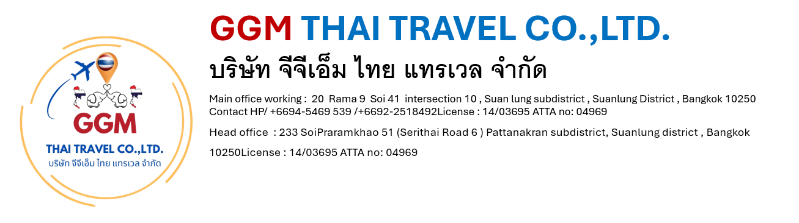

Chiang Mai – Chiang Rai (Overnight) 5 Days/4 Nights

Tour Highlights: Old City & City Gate / Chedi Luang Temple / Phrasing Temple / Kantoke Dinner / Elephant Sanctuary / Wat Phrathat Doi Suthep / Doi Inthanon National Park / Chiang Rai / White Temple / Blue Temple / Black House Mueum / Karen Long Neck / Doi Tung Villa / Golden Triangle / Chiang Mai Home Industries
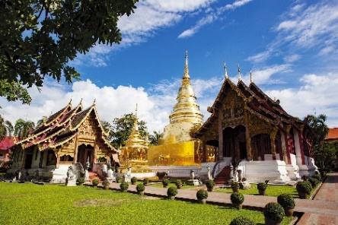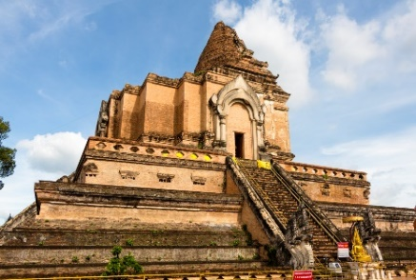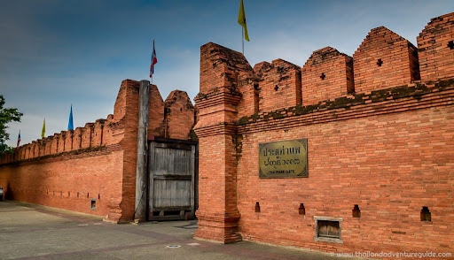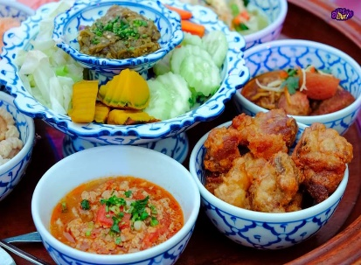

Day 1: Arrival Day - City Tour – Kantoke Dinner (-/-/D)
• Morning / Afternoon - Warmly welcome at Chiang Mai Airport
• City Tour around the old city of Chiang Mai where's surrounded by the ancient wall.
• Visit Phra Sing Temple, Chedi Luang Temple and Tha Pae Gate
• 18.00 - 20.30 pm. Have a Kantoke Dinner with a Northern Thai food dinner and Thai tradition dancing performance at Khum Kantoke Restaurant
• Transfer to check in at hotel in Chiang Mai town, free and easy.

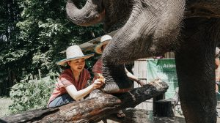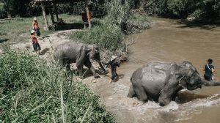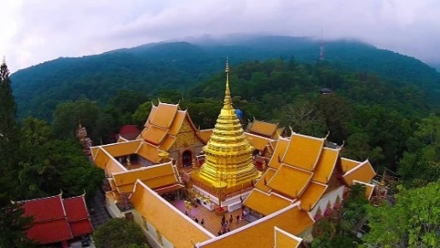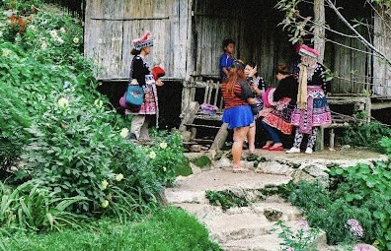
Day 2: Doi Suthep Temple - Elephants Care (B/L/D)
• 09.00 am. Pickup at hotel and departure to the north route of Chiang Mai to Mae Rim district
• 09.45 am. Visit to Mae Rim Elephant Home to enjoy with 2 hours Elephants Care (Learning, Elephant Foot Care, Walking with elephants, Feeding, Mud Bathing, Bathing in the river)
• 12.00 pm. Have a local lunch with Pad Thai and fresh fruits
• Afternoon, Drive up to the mountain to visit Doi Suthep Temple, the most important temple in Chiangmai with an impressive city view.
• Visit Hmong Doi-Pui Hilltribe Village
• 17.30 pm. Have a dinner at local restaurant
• 19.00 pm. Transfers to hotel, free and easy.

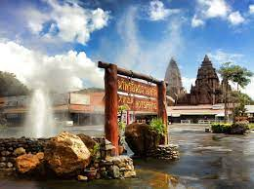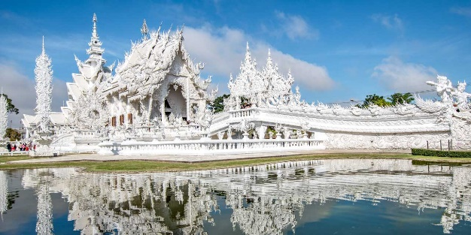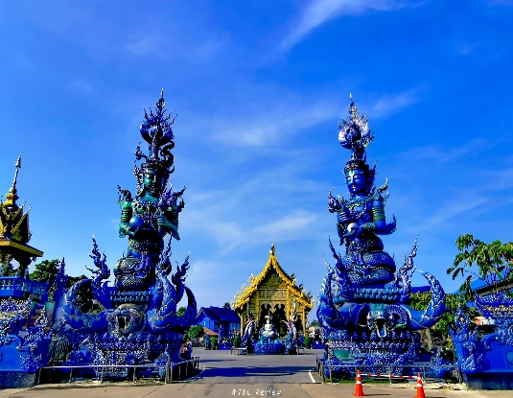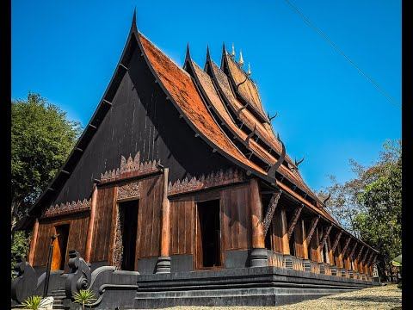
Day 3: Chiang Mai – Chiang Rai (B/L/D)
• 08.00 am. Pick up at hotel and departure to Chiang Rai around 3 – 3.5 hours
• Take a short break at Mae Kajarn Hotspring
• Visit White Temple (Wat Rong Khun)
• 12.30 pm. Lunch at local restaurant
• Visit Blue Temple (Wat Rong Sue Ten)
• Visit Black House Museum
• 17.30 pm. Have a dinner at local restaurant
• 19.00 pm. Transfers to hotel to check in, free and easy.
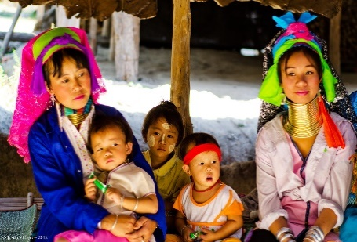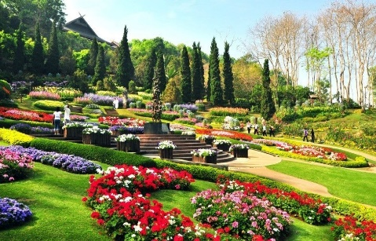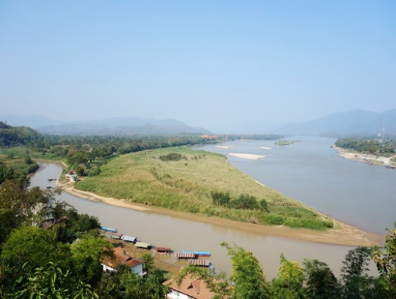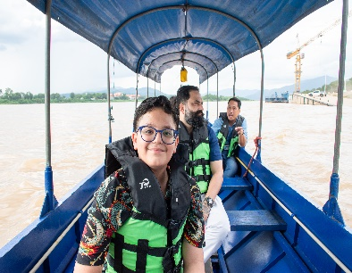
Day 4: Chiang Rai – Chiang Mai (B/L/D)
• 08.30 am. Pick up at hotel
• Visit Doi Tung Royal Winter Palace and Mae Fah Luang Royal Garden
• 12.00 pm. Lunch at local restaurant
• Visit Golden Triangle to see the 3 borders meeting view point (Laos, Myanmar and Thailand)
• Boat trip along Mae Khong river
• Visit Karen Long Neck & Hilltribes Village
• Driving back to Chiang Mai and have a dinner at local restaurant
• 21.00 / 21.30 pm. Transfers to hotel in Chiang Mai to check in and relax.

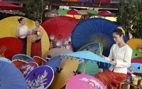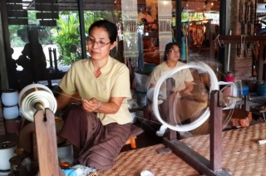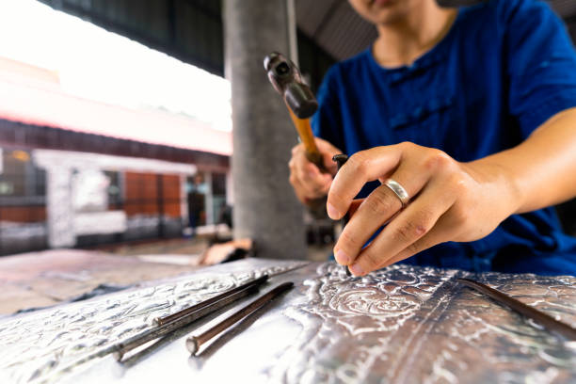
Day 5 : Home Industries - Departure Day (B/L/-)
• 09.00 am. Pick up at hotel.
• Visit San Kampeang Handicraft Village is well known of hand made product such as umbrella making, silver ware, lacquer ware, Thai silk, gems stone and wood carving.
• 12.00 pm. Lunch at local restaurant
• Afternoon – Transfers to Chiang Mai Airport (Depends on the flight.)

